CI CD LAB EXPERIMENT -9

(BY: AMAN TYAGI)

Aim: Uploading artifacts on Nexus using Command Line

1. Download Sonatype Nexus from https://www.sonatype.com/nexus/repository-oss/download

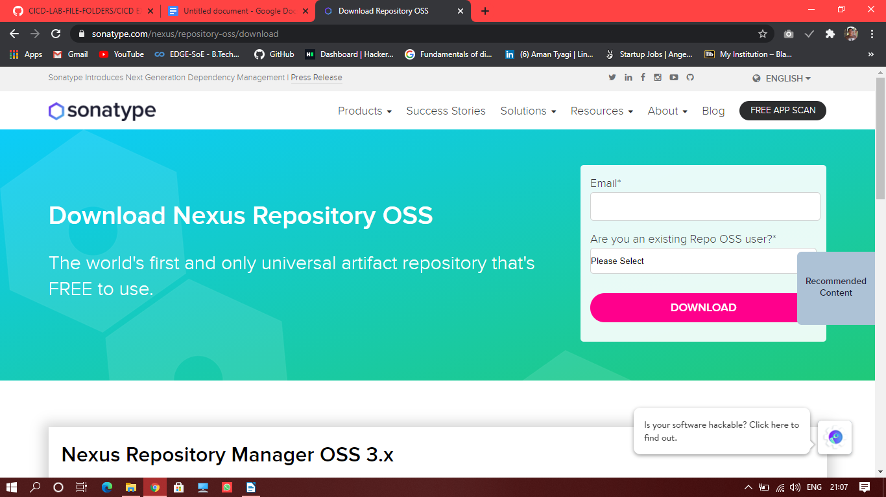

1. Go to downloaded folder , and find “nexus.exe” file in the bin folder
2. Open the command prompt and change the directory to the “nexus.exe” directory and run “nexus.exe /run”

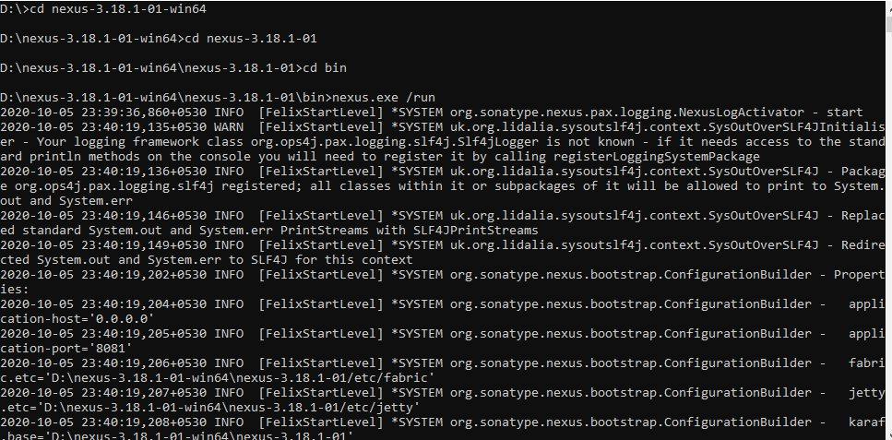

1. Go to localhost:8080 (For the first time, nexus requests the admin password. You will find it in **sonatype-work\nexus3** folder with the name admin.password)

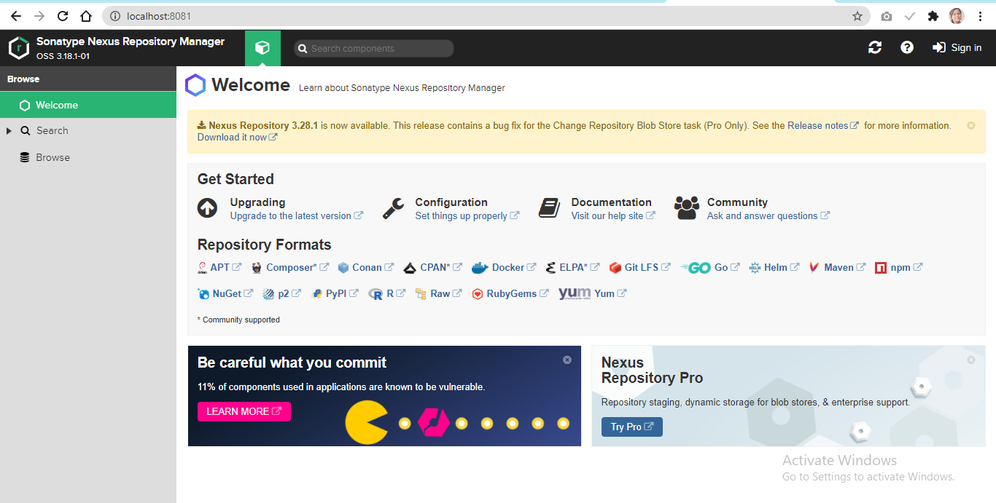

1. Create a new repository in Nexus and copy its url

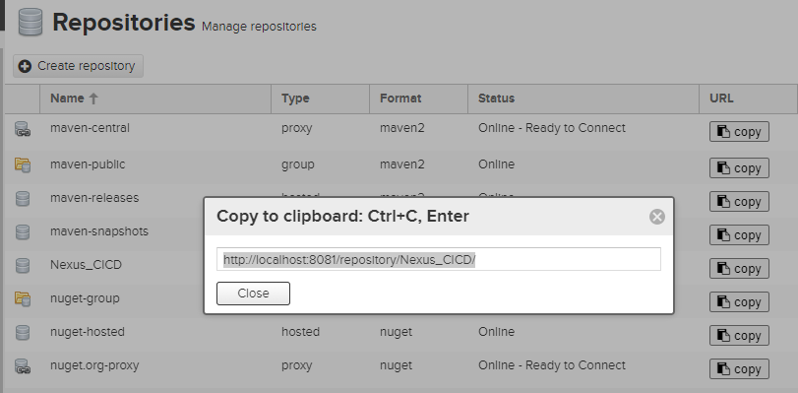

1. Open the pom.xml of the maven project which you want to be published to Nexus.
2. Add the snapshotRepository tag into the pom.xml and give the URL of Nexus repository copied.

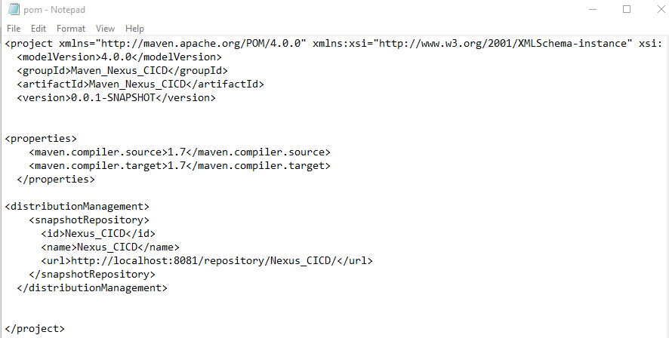

1. In the settings.xml file add the server tag with the credentials

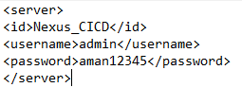

1. Now open command prompt and run “mvn clean”, “mvn install”

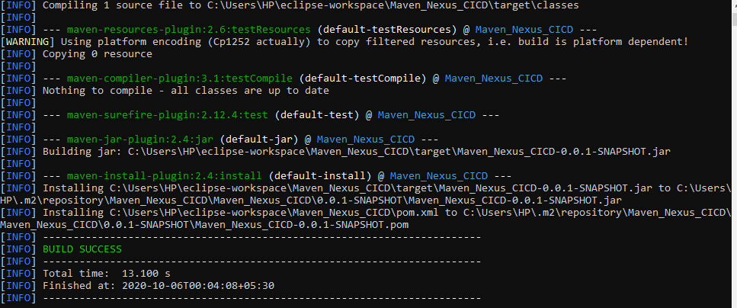

1. Run “mvn deploy” and it should be success and see the jar file on nexus

